Deploy Large Language Models (LLM) in Microsoft Foundry
- Login to Azure Portal.

- Go to Microsoft Foundry Project to access and deploy LLM.

- Click Discover menu item to get to Models.

- Click Models menu item to see available Models and Embeddings.
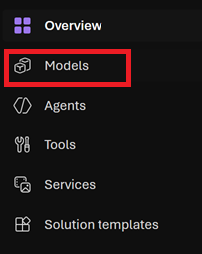
- Verify Available in my project is selected to see all models available to your project and region.
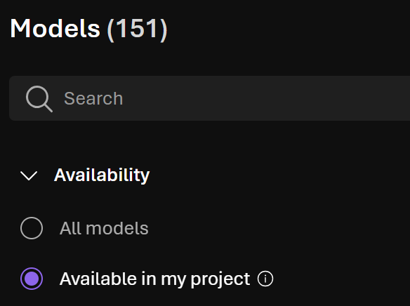

- Select the Region the LLM should be supported in. Note, this should be the same region as your Foundry Project.
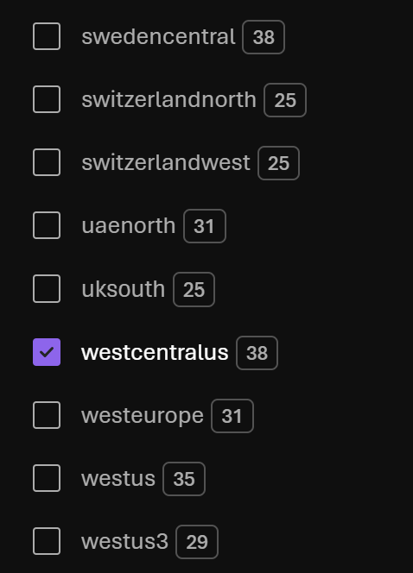
- Enter LLM Search Criteria in Search textbox.
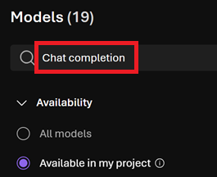
- Double-click on desired LLM to start LLM deployment process.
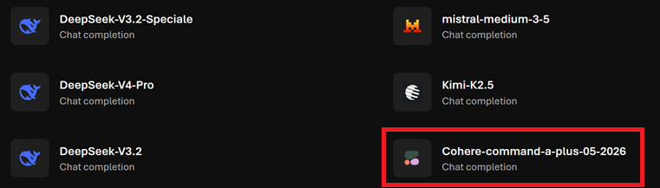

- Click Deploy button and then click Custom settings.
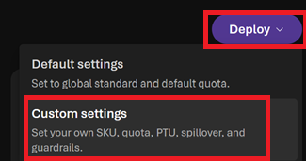
- Add suffix to Deployment name to make the LLM name unique.
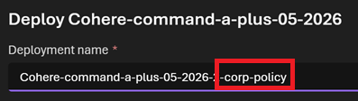
- Click Deploy button to deploy the LLM.
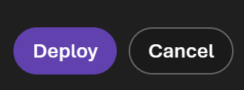
- Click Deployments to verify LLM has been deployed.
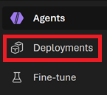

- Verify LLM has been deployed.
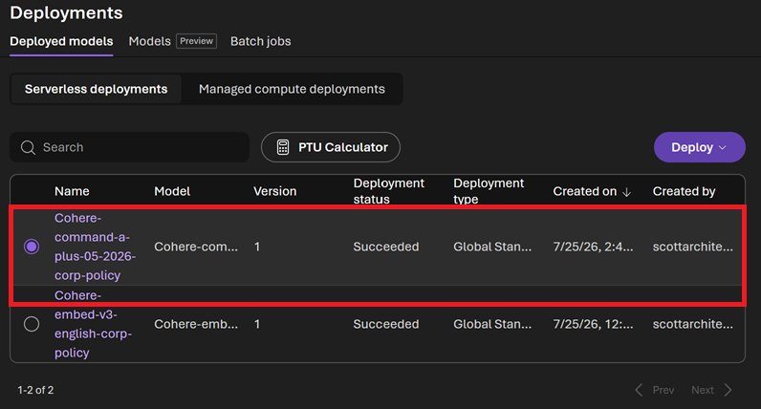
- Finished.

